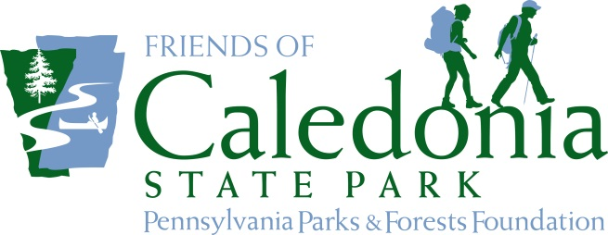

THE

NEWS

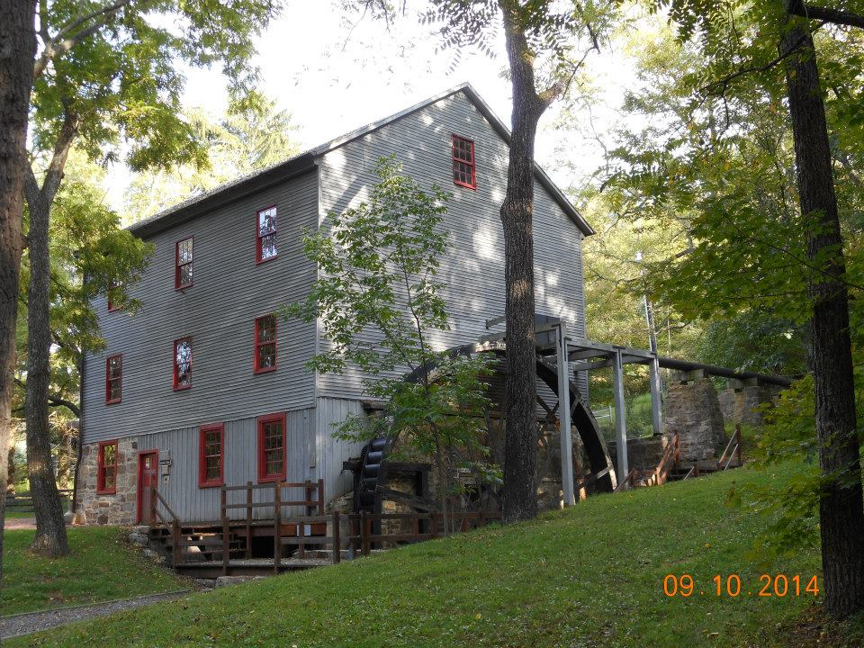

First Edition – Volume 1, #1

ABOUT THE FRIENDS

Whether it’s contact information, a meeting schedule, your next volunteer day, membership drive or big event – use this spot to highlight something big and important that should come to everyone’s immediate attention. It could be static from one issue to the next, ever changing or a combination of the two.

For example:

Visit us online at:

www.FriendsofLittleBuffalo.org

Follow us on Facebook at:

www.facebook.com/FOLB

Annual membership in the Friends costs only $15.

Join Today!

Name:

Address:

Email:

Phone:

Make your check payable to “PPFF” and mail it to us at:

PO Box 1, Anytown, PA 15555

July 2015

Lorem ipsum dolor sit amet, consectetur adipiscing elit, sed do eiusmod tempor incididunt ut labore et dolore magna aliqua. Ut enim ad minim veniam, quis nostrud exercitation ullamco laboris nisi ut aliquip ex ea commodo consequat. Duis aute irure dolor in reprehenderit in voluptate velit esse cillum dolore eu fugiat nulla pariatur. Excepteur sint occaecat cupidatat non proident, sunt in culpa qui officia deserunt mollit anim id est laborum.

Lorem ipsum dolor sit amet, consectetur adipiscing elit, sed do eiusmod tempor incididunt ut labore et dolore magna aliqua. Ut enim ad minim veniam, quis nostrud exercitation ullamco laboris nisi ut aliquip ex ea commodo consequat. Duis aute irure dolor in reprehenderit in voluptate velit esse cillum dolore eu fugiat nulla pariatur. Excepteur sint occaecat cupidatat non proident, sunt in culpa qui officia deserunt mollit anim id est laborum.

Lorem ipsum dolor sit amet, consectetur adipiscing elit, sed do eiusmod tempor incididunt ut labore et dolore magna aliqua. Excepteur sint occaecat cupidatat non proident, sunt in culpa qui officia deserunt mollit anim id est laborum.

Little Buff is where you can learn about history.

# HEADLINE NEWS

Your Chapter’s Big Story

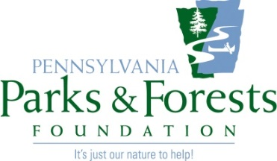

A Secondary Item of Interest

July is a time for swimming pools and warm weather fun. Little Buff is the perfect place to give it a try!

Lorem ipsum dolor sit amet, consectetur adipiscing elit, sed do eiusmod tempor incididunt ut labore et dolore magna aliqua. Ut enim ad minim veniam, quis nostrud exercitation ullamco laboris nisi ut aliquip ex ea commodo consequat. Duis aute irure dolor in reprehenderit in voluptate velit esse cillum dolore eu fugiat nulla pariatur. Excepteur sint occaecat cupidatat non proident, sunt in culpa qui officia deserunt mollit anim id est laborum.

Lorem ipsum dolor sit amet, consectetur adipiscing elit, sed do eiusmod tempor incididunt ut labore et dolore magna aliqua. Ut enim ad minim veniam, quis nostrud exercitation ullamco laboris nisi ut aliquip ex ea commodo consequat. Duis aute irure dolor in reprehenderit in voluptate velit esse cillum dolore eu fugiat nulla pariatur. Excepteur sint occaecat cupidatat non proident, sunt in culpa qui officia deserunt mollit anim id est laborum.

Excepteur sint occaecat cupidatat non proident, sunt in culpa qui officia deserunt mollit anim id est laborum.

Lorem ipsum dolor sit amet, consectetur adipiscing elit, sed do eiusmod tempor incididunt ut labore et dolore magna aliqua. Ut enim ad minim veniam, quis nostrud exercitation ullamco laboris nisi ut aliquip ex ea commodo consequat. Duis aute irure dolor in reprehenderit in voluptate velit esse cillum dolore eu fugiat nulla pariatur. Excepteur sint occaecat cupidatat non proident, sunt in culpa qui officia deserunt mollit anim id est laborum.

# more news

# STATEWIDE NEWS

A Few Words from the Pennsylvania Parks & Forests Foundation

In this space, we’ll share a news item of statewide important in each issue. It will either be an event we’re hosting, an issue that should be of concern to all state park and forest users, a fun item or whatever.

These columns, the logo and title are all locked into place so that no matter what happens higher up on the page, these things will stay where they are, so that when I send you the quarterly template, these things won’t move.

That makes things a whole lot easier for all of us. So we hope you will give this idea a try, communicating with your members and supporters by mail, turning this into a pdf and leaving some copies in your park or forest office or adding it to your Facebook page or website, or slipping it into an email so that everyone begins to know who you are and the great work that you are doing.

Remember how important we have said it is to communicate with the people who give you money.

And besides. It’s your horn – toot it!

***www.PAParksandForests.org***