(YOUR LOGO) December 10, 2019

(Addressee)

Dear (Salutation)

You may have heard that the Friends of ______ is working to raise money to ___ and we’d like to ask you for your support of this project.
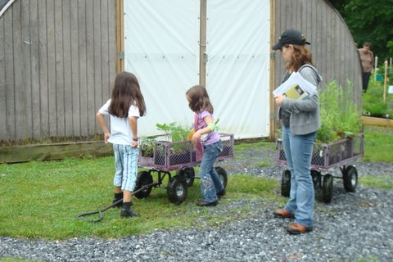
The Friends has a track record of accomplishment at _____. (Tell them what you’ve done – successful events, trails built, playgrounds installed, etc.) With your financial assistance, we can take these accomplishments one step further.
Caption the Photo
Include a little explanation as to the importance of the project you’re raising money for now. Who will it help? What will it do? Think about including a picture of something you’ve done in the past.

Thank you again for your support and enthusiasm for the work of the Friends. We look forward to seeing you at ___________.

Sincerely,

Name,
Chair

