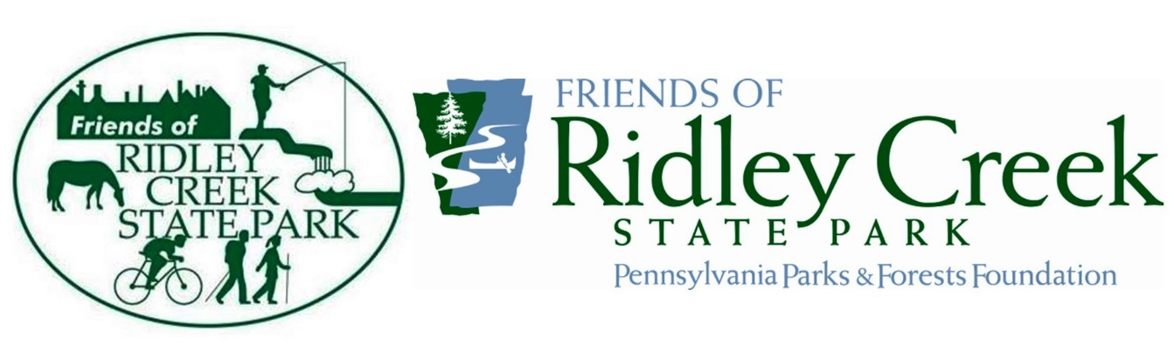

The Friends of Ridley Creek State Park (Friends) is looking for a new Board Treasurer. The ideal candidate for this volunteer position would have non-profit board experience and a passion for Ridley Creek State Park and the environment. You will receive training by the former Treasurer.
The Friend's funds are managed by our parent organization, the Pennsylvania Parks & Forests Foundation (PPFF), headquartered in Harrisburg. As Treasurer you will communicate with the PPFF bookkeeper to maintain accurate and up-to-date records of our funds. You will collect and process membership dues and donation checks, if mailed, and keep accurate records of donations.
The Treasurer's responsibilities are:
Must have access to Microsoft Excel, printer, copier and digital scanner.
Manage and have oversight of all aspects of the Friend’s finances.
Process reimbursement requests from other Board members.
If possible, pick up mail from the Friend's mailbox in the park office (M-F 8am-4pm).
Send info on new memberships and renewals to Membership Chair (if dues have been mailed).
Be available for Board meetings, held several times a year.
If you are interested, please send a letter to Jack Miller at president@friendsofrcsp.org
Thank you!

