[ organization logo ]

January 29, 2026

First Name Last Name
Address 1
Address 2
City, PA Zip Code

Dear First Name,

[attention getting opening line]

[story about ONE person]

Because of your support (or because of the support of community members like you) …
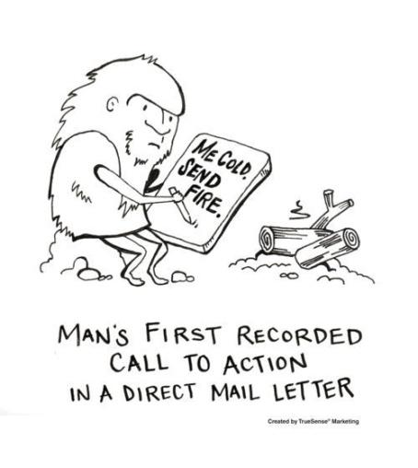
[information about the program / organization – remember to give the donor credit]

[setup the ask]

I hope you will join me TODAY in making donation of $XXX. A reply card and return envelope is enclosed for your convenience, or you can make a secure donation online at ________________.
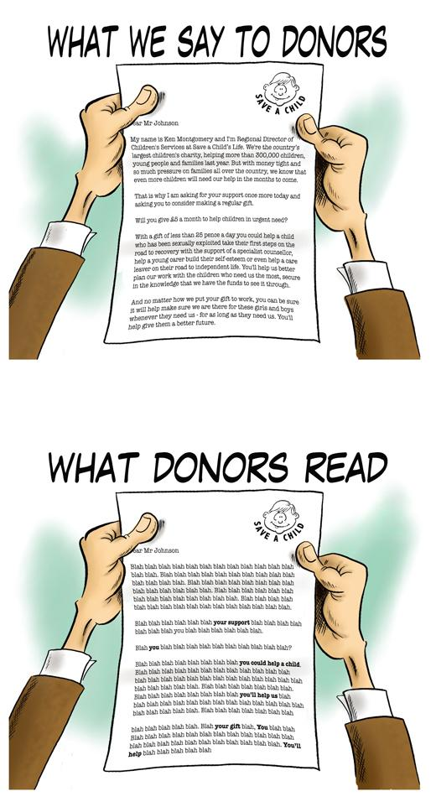
[show urgency]

Without you, this would not be possible …

On behalf of the many _______ who benefit from your generosity, THANK YOU in advance for your support. Your support makes a difference in the lives of our ________.

With Gratitude,

[signer], [title]

P.S. Please reply TODAY to ensure that ______________!

